**Result 1 – Daily mail with info on number of Tasks in repository :**

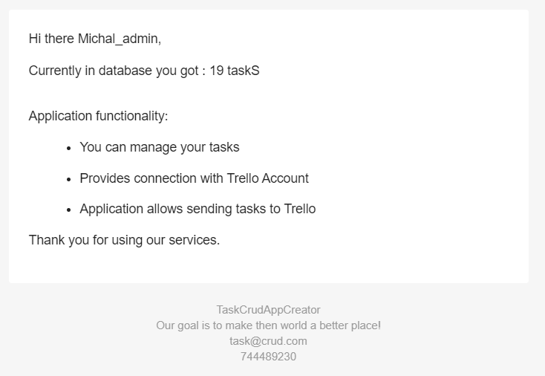

**Result 2 – Mail with info on newly created Trello Card :**

